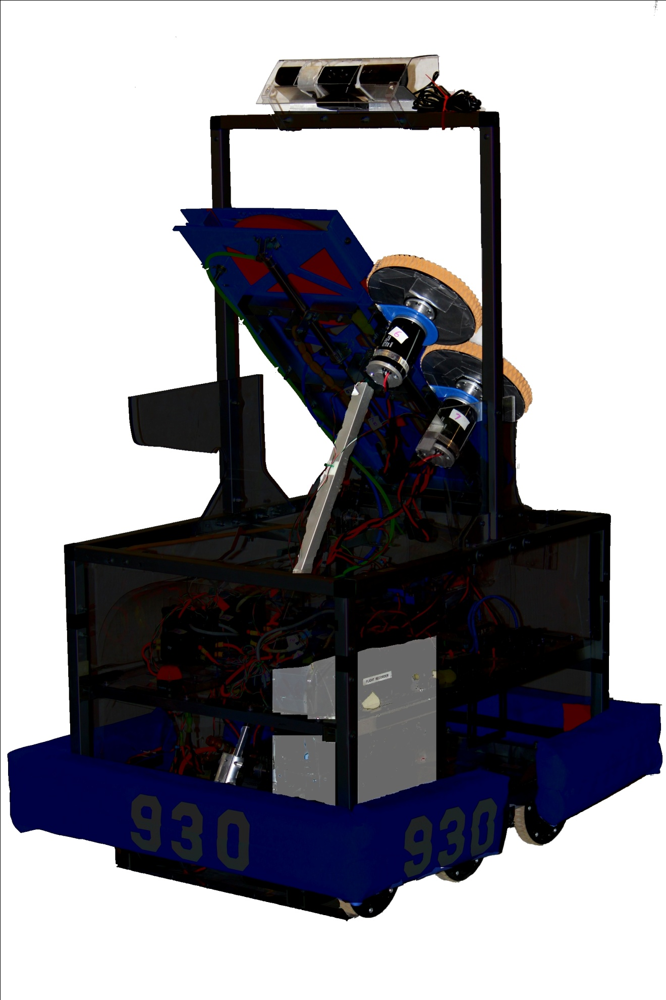

Ball screw: Closed loop with PID with potentiometer

Kinect: Used to track the targets

Shooter: closed loop PID control with encoders

Drive Train: closed loop PID control with encoders

Onboard PC: recieves Kinect data and processes it into shooter information